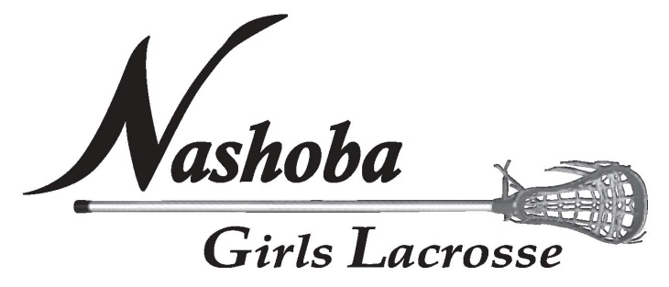

Photo Release Form

I hereby grant permission to Nashoba Girls Lacrosse (“NGL”) to use any
photographs taken from other team parents or a member of NGL and post them on the
NGL website, www.nashobagirlslacrosse.org or social media page (Facebook). These photographs will be representing and promoting NGL during practice, games and jamborie on the NGL website and/or social media page only. I acknowledge NGL has the right to crop or treat the photograph at its discretion for formatting purposes. I also acknowledge that NGL may choose not to use any photograph at this time, but may do so, at its own discretion, at a later date. I also understand that once a photograph is posted on the NGL website or social media page, the photograph can be downloaded by any computer user. Therefore, I agree to hold NGL harmless from any claims.

􀂅 Yes. I have read and agree to all terms stated above and authorize NGL to use
photographs of my child on the NGL website or social media page.
􀂅 No. I do not authorize NGL to use my child’s photograph on the NGL website or
social media page.

Coaches Name: Check Appropriate Division/Age Group
􀂅 U9 􀂅 U11 􀂅 U13 􀂅 U15
Player’s Name: Parent/Guardian Name:

Parent/Guardian Signature: Date:

